

SCHOOL OF COMPUTING AND INFORMATION TECHNOLOGY

Web Technology Applications Lab

B20CI0504

For

Fifth Semester

B. Tech in Computing and Information Technology

|  |  |
| --- | --- |
| NAME |  |
| SRN |  |
| SEM |  |
| SECTION |  |
| BRANCH |  |
| ACADEMIC YEAR |  |

**LAB QUESTIONS**

|  |  |  |
| --- | --- | --- |
| **SL NO** | **Lab Programs** | **PAGE NO** |
| **01** | 1. In today’s digital world, information dissemination through printed documents consume lot of time. To overcome this drawback it is better to adopt digital technology for information dissemination, like e-journals, e-books, e-advertisements, etc. Information dissemination through Internet in the form of web content is essential and convenient option. Design and develop static web pages for an online Book store. The pages should resemble like www.amazon.com The website should consist of. Home page, Registration & Login, User profile page, Books catalog, Shopping cart, Payment by credit card, and order confirmation. | **26** |
| **02** | 1. Internet or online services works on clients and server model. A client is a web browser through which users make requests, which contain input required, for service from the server to perform tasks. Server is a program running on a dedicated computer. Performance of any service or server depends on its throughput. Server throughput deteriorates when users send more and more invalid requests for service and thus results in wastage of server resources that are very precious.  As a solution to this problem design a web page that takes student details such as Name, branch, Semester, University, date of admission, mobile number, email id and check for validity or correctness of the input data by writing a JavaScript to validate these fields. | **31** |
| **03** | 1. Clients interact with servers by sending service requests that contain input required to complete the requested task or service. Input required for requested service may be collected through a web page, that acts as an interface between users and the server, in the form of text fields, text areas, radio buttons, push buttons and so on. Hence it is better to instruct or help clients to input correct data through web page by displaying appropriate error messages or alerts as and when users supply wrong input using event handlers. To demonstrate this task, design and develop a web page using JavaScript, XHTML that collects the SRN (Valid format is: Any letter followed by two digits, followed by two letters then followed by three digits). Include event handler for the form elements that collects information to validate the input. Messages must be produced in the alert windows as and when errors are detected. | **34** |

|  |  |  |
| --- | --- | --- |
| **04** | 1. Dynamic web content is the information that is retrieved from one or more web servers depending upon what information client have requested for, and composed in response to users’ requests. Advanced web technologies play a vital role in storage, processing and retrieval of dynamic web content from web servers. Hence it is important to use advanced web technologies such as XML to improve the efficiency in data retrieval. Create and save XML document for students information and display the same using cascaded style sheet. | **36** |
| **05** | 1. Information technology has become part and parcel of humanity to such an extent that people can shop anything online, from anywhere, at any time using an electronic device that has access to Internet. This has brought in the concept of virtual stores which provide products at less cost. To improve sales it is mandatory to organize items catalog based on item name, item price, and manufacturer so on. For such online shopping sites, look and feel is an obvious requirement which can be achieved using CSS & XSLT. Design a document using CSS and XSLT to create a catalog of items for an online electronic shopping. | **38** |
| **06** | 1. In any business organization, employees keep traveling across different geographical locations and at the same time they want to be connected to their organization’s computing resources such as email server, database server, file server, etc. to retrieve information such as sales details, assigning tasks to employees, and upload inspection site details, so on. Using PHP develop a web page that accepts book information such as ISBN number, title, authors, edition and publisher and store information submitted through web page in MySQL database. Design another web page to search for a book based on book title specified by the user and displays the search results with proper headings. | **41** |
| **07** | 1. Using computers without graphical user interfaces require the knowledge about syntax of computer commands and programming languages, also this makes users to feel that the use of computers is difficult and cumbersome. This impression of users on computers can be changed by providing good and easy-to-use graphical user interfaces which play vital role in use of computer applications or software without worrying about syntax of programming languages or computer commands. In fact computer software with good and easy-to-use graphical user interfaces will have large number of users. a) Design HTML page that takes UNIX command as input in a text field and submit it to a Perl program that executes given command and display the output on the web page b) Write a Perl program to keep track of the number of visitors to a web page and display the count of visitors with proper headings | **44** |

|  |  |  |
| --- | --- | --- |
| **08** | 1. Databases are the storage systems used by most of the business and information technology enterprises as back end. When users generate data using GUI, for ex. personal information, data are sent to back end database for storage and also users can retrieve this data as and when required from the back end (database) to the front GUI. In the real world there are several databases such as Oracle, DB2, MySQL, SQL Server, MS-Access, DBMongo, etc. To illustrate the process of generating data from the front end and store it on back end database then retrieve the available data from the back end database, write a Perl program to read personal information of a person such as first name, last name, age, permanent address and pin code entered by the user into a table created in MySQL. Read the same information from the database and display on the front end. | **46** |
| **09** | 1. Write a PHP program to store current date-time in a COOKIE and display the ‘Last visited on’ date-time on the web page upon reopening of the same page. | **48** |
| **10** | 1. Write a PHP program to store page views count in SESSION, to increment the count on each refresh, and to show the count on web page. | **49** |

# Introduction

This lab is intended to give the students a sound knowledge in the Web side programming. Before going in to the details of the lab, the prerequisites are the basic knowledge in HTML, XHTML, CSS, XML, JavaScript, Perl, PHP, Ruby and MySql.

# Basics of HTML: -

Hyper Text Markup Language (HTML) is a markup language developed by the W3C people. This can be used as an interface for working our programs. We submit all our requests in the HTML form. It is basically a markup language which describes how the documents are to be formatted.

HTML has two basic entities, the “Tags” (Formatting commands) and the strings within the tags called as the “Directives”. Most of the tags have the following syntax: - <something> that indicates the beginning of the tag and a</something> that indicates the end of the tag.

*NOTE:*

* Tags can either be in lower case or uppercase, i.e. there is no difference between<html> and<HTML>
* The order in which parameters of the tagaret given is not significant since each of these parameters is named.

**HTML is the standard markup language for Web pages.**

**With HTML you can create your own Website.**

## **What is HTML?**

* HTML stands for Hyper Text Markup Language
* HTML is the standard markup language for creating Web pages
* HTML describes the structure of a Web page
* HTML consists of a series of elements
* HTML elements tell the browser how to display the content
* HTML elements label pieces of content such as "this is a heading", "this is a paragraph", "this is a link", etc.

## **A Simple HTML Document**

### **Example**

<!DOCTYPE html>  
<html>  
<head>  
<title>Page Title</title>  
</head>  
<body>  
<h1>My First Heading</h1>  
<p>My first paragraph.</p>  
</body>  
</html>

**Example Explained**

* The <!DOCTYPE html> declaration defines that this document is an HTML5 document
* The <html> element is the root element of an HTML page
* The <head> element contains meta information about the HTML page
* The <title> element specifies a title for the HTML page (which is shown in the browser's title bar or in the page's tab)
* The <body> element defines the document's body, and is a container for all the visible contents, such as headings, paragraphs, images, hyperlinks, tables, lists, etc.
* The <h1> element defines a large heading
* The <p> element defines a paragraph

**What is an HTML Element?**

**An HTML element is defined by a start tag, some content, and an end tag:**

<tagname> Content goes here... </tagname>

The HTML **element** is everything from the start tag to the end tag:

<h1>My First Heading</h1>

<p>My first paragraph.</p>

## **HTML Links**

**HTML links are defined with the <a> tag:**

### **Example**

<a href="https://reva.edu.in">This is a link</a>

## **HTML Images**

**HTML images are defined with the <img> tag.**

**The source file (src), alternative text (alt), width, and height are provided as attributes:**

### **Example**

<img src="sample.jpg" alt="reva.edu.in" width="104" height="142">

## **The alt Attribute**

The required alt attribute for the <img> tag specifies an alternate text for an image, if the image for some reason cannot be displayed. This can be due to slow connection, or an error in the src attribute, or if the user uses a screen reader.

<img src="img_girl.jpg" alt="Girl with a jacket">

<img src="img_girl.jpg" width="500" height="600">

## **The width and height Attributes**

The <img> tag should also contain the width and height attributes, which specifies the width and height of the image (in pixels):

### **Example**

<img src="img_girl.jpg" width="500" height="600">

## **HTML is Not Case Sensitive**

HTML tags are not case sensitive: <P> means the same as <p>.

The HTML standard does not require lowercase tags, and **demands** lowercase for stricter document types like XHTML.

The <br> tag defines a line break, and is an empty element without a closing tag:

**Example**

<p>This is a <br> paragraph with a line break.</p>

## **The style Attribute**

The style attribute is used to add styles to an element, such as color, font, size, and more.

<*tagname* style="*property*:*value;*">

The ***property*** is a CSS property. The ***value*** is a CSS value.

### Example

<p style="color:red;font-size:30px;font-style:italic">This is a red paragraph.</p>

## **Background Color**

The CSS background-color property defines the background color for an HTML element.

### **Example**

Set the background color for a page to powderblue:

<body style="background-color:powderblue;">  
  
<h1>This is a heading</h1>  
<p>This is a paragraph.</p>  
  
</body>

<body>  
  
<h1 style="background-color:powderblue;">This is a heading</h1>  
<p style="background-color:tomato;">This is a paragraph.</p>  
  
</body>

## **Text Color**

The CSS color property defines the text color for an HTML element:

### **Example**

<h1 style="color:blue;">This is a heading</h1>  
<p style="color:red;">This is a paragraph.</p>

## **Fonts**

The CSS font-family property defines the font to be used for an HTML element:

### Example

<h1 style="font-family:verdana;">This is a heading</h1>  
<p style="font-family:courier;">This is a paragraph.</p>

## **Text Size**

The CSS font-size property defines the text size for an HTML element:

### Example

<h1 style="font-size:300%;">This is a heading</h1>  
<p style="font-size:160%;">This is a paragraph.</p>

## **Text Alignment**

The CSS text-align property defines the horizontal text alignment for an HTML element:

### Example

<h1 style="text-align:center;">Centered Heading</h1>  
<p style="text-align:center;">Centered paragraph.</p>

## **HTML Formatting Elements**

Formatting elements were designed to display special types of text:

* <b> - Bold text
* <strong> - Important text
* <i> - Italic text
* <em> - Emphasized text
* <mark> - Marked text
* <small> - Smaller text
* <del> - Deleted text
* <ins> - Inserted text
* <sub> - Subscript text
* <sup> - Superscript text

## **HTML Comment Tag**

You can add comments to your HTML source by using the following syntax:

<!-- Write your comments here -->

## **HTML Horizontal Rules**

The <hr> tag defines a thematic break in an HTML page, and is most often displayed as a horizontal rule.

The <hr> element is used to separate content (or define a change) in an HTML page:

### Example

<h1>This is heading 1</h1>  
<p>This is some text.</p>  
<hr>  
<h2>This is heading 2</h2>  
<p>This is some other text.</p>  
<hr>

## **Border Color**

You can set the color of borders:

## Hello World

## Hello World

## Hello World

### Example

<h1 style="border:2px solid Tomato;">Hello World</h1>  
<h1 style="border:2px solid DodgerBlue;">Hello World</h1>  
<h1 style="border:2px solid Violet;">Hello World</h1>

## What is CSS?

Cascading Style Sheets (CSS) is used to format the layout of a webpage.

With CSS, you can control the color, font, the size of text, the spacing between elements, how elements are positioned and laid out, what background images or background colors are to be used, different displays for different devices and screen sizes, and much more!

## **Using CSS**

CSS can be added to HTML documents in 3 ways:

* **Inline** - by using the style attribute inside HTML elements
* **Internal** - by using a <style> element in the <head> section
* **External** - by using a <link> element to link to an external CSS file

## Inline CSS

An inline CSS is used to apply a unique style to a single HTML element.

An inline CSS uses the style attribute of an HTML element.

The following example sets the text color of the <h1> element to blue, and the text color of the <p> element to red:

### Example

<h1 style="color:blue;">A Blue Heading</h1>  
  
<p style="color:red;">A red paragraph.</p>

## **Internal CSS**

An internal CSS is used to define a style for a single HTML page.

An internal CSS is defined in the <head> section of an HTML page, within a <style> element.

The following example sets the text color of ALL the <h1> elements (on that page) to blue, and the text color of ALL the <p> elements to red. In addition, the page will be displayed with a "powderblue" background color:

### **Example**

<!DOCTYPE html>  
<html>  
<head>  
<style>  
body {background-color: powderblue;}  
h1   {color: blue;}  
p    {color: red;}  
</style>  
</head>  
<body>  
<h1>This is a heading</h1>  
<p>This is a paragraph.</p>  
</body>  
</html>

## **External CSS**

An external style sheet is used to define the style for many HTML pages.

To use an external style sheet, add a link to it in the <head> section of each HTML page:

### **Example**

<!DOCTYPE html>  
<html>  
<head>  
  <link rel="stylesheet" href="styles.css">  
</head>  
<body>  
  
<h1>This is a heading</h1>  
<p>This is a paragraph.</p>  
  
</body>  
</html>

The external style sheet can be written in any text editor. The file must not contain any HTML code, and must be saved with a .css extension.

Here is what the "styles.css" file looks like:

"styles.css":

body {  
  background-color: powderblue;  
}  
h1 {  
  color: blue;  
}  
p {  
  color: red;  
}

<!DOCTYPE html>  
<html>  
<head>  
<style>  
h1 {  
  color: blue;  
  font-family: verdana;  
  font-size: 300%;  
}  
p {  
  color: red;  
  font-family: courier;  
  font-size: 160%;  
}  
</style>  
</head>  
<body>  
  
<h1>This is a heading</h1>  
<p>This is a paragraph.</p>  
  
</body>  
</html>

## **CSS Border**

The CSS border property defines a border around an HTML element.

**Tip:** You can define a border for nearly all HTML elements.

### **Example**

Use of CSS border property:

p {  
  border: 2px solid powderblue;  
}

## **CSS Padding**

The CSS padding property defines a padding (space) between the text and the border.

### Example

Use of CSS border and padding properties:

p {  
  border: 2px solid powderblue;  
  padding: 30px;  
}

## **CSS Margin**

The CSS margin property defines a margin (space) outside the border.

### **Example**

Use of CSS border and margin properties:

p {  
  border: 2px solid powderblue;  
  margin: 50px;  
}

## **Define an HTML Table**

<!DOCTYPE html>

<html>

## <style>

## table, th, td {

## border:1px solid black;

## }

## </style>

## <body>

## <h2>A basic HTML table</h2>

## <table style="width:100%">

## <tr>

## <th>Company</th>

## <th>Contact</th>

## <th>Country</th>

## </tr>

## <tr>

## <td>Alfreds Futterkiste</td>

## <td>Maria Anders</td>

## <td>Germany</td>

## </tr>

## <tr>

## <td>Centro comercial Moctezuma</td>

## <td>Francisco Chang</td>

## <td>Mexico</td>

## </tr>

## </table>

## <p>To undestand the example better, we have added borders to the table.</p>

## </body>

## </html>

## <p>To undestand the example better, we have added borders to the table.</p>

## </body>

## </html>

## Table Cells

Each table cell is defined by a <td> and a </td> tag.

td stands for table data.

Everything between <td> and </td> are the content of the table cell.

### Example

<!DOCTYPE html>

<html>

<style>

table, th, td {

border:1px solid black;

}

</style>

<body>

<h2>TD elements define table cells</h2>

<table style="width:100%">

<tr>

<td>Emil</td>

<td>Tobias</td>

<td>Linus</td>

</tr>

</table>

<p>To undestand the example better, we have added borders to the table.</p>

</body>

</html>

## Collapsed Table Borders

<!DOCTYPE html>

<html>

<head>

<style>

table, th, td {

border: 1px solid black;

border-collapse: collapse;

}

</style>

</head>

<body>

<h2>Collapsed Borders</h2>

<p>If you want the borders to collapse into one border, add the CSS border-collapse property.</p>

<table style="width:100%">

<tr>

<th>Firstname</th>

<th>Lastname</th>

<th>Age</th>

</tr>

<tr>

<td>Jill</td>

<td>Smith</td>

<td>50</td>

</tr>

<tr>

<td>Eve</td>

<td>Jackson</td>

<td>94</td>

</tr>

<tr>

<td>John</td>

<td>Doe</td>

<td>80</td>

</tr>

</table>

</body>

</html>

## HTML Table – Colspan

## Cell that spans two columns

To make a cell span more than one column, use the colspan attribute.

|  |  |  |
| --- | --- | --- |
| **Name** | | **Age** |
| Jill | Smith | 43 |
| Eve | Jackson | 57 |

To make a cell span over multiple columns, use the colspan attribute:

<!DOCTYPE html>

<html>

<head>

<style>

table, th, td {

border: 1px solid black;

border-collapse: collapse;

}

</style>

</head>

<body>

<h2>Cell that spans two columns</h2>

<p>To make a cell span more than one column, use the colspan attribute.</p>

<table style="width:100%">

<tr>

<th colspan="2">Name</th>

<th>Age</th>

</tr>

<tr>

<td>Jill</td>

<td>Smith</td>

<td>43</td>

</tr>

<tr>

<td>Eve</td>

<td>Jackson</td>

<td>57</td>

</tr>

</table>

</body>

</html>

## HTML Table – Rowspan

## Cell that spans two rows

To make a cell span more than one row, use the rowspan attribute.

|  |  |
| --- | --- |
| **Name** | Jill |
| **Phone** | 555-1234 |
| 555-8745 |

To make a cell span over multiple rows, use the rowspan attribute:

<!DOCTYPE html>

<html>

<head>

<style>

table, th, td {

border: 1px solid black;

border-collapse: collapse;

}

</style>

</head>

<body>

<h2>Cell that spans two rows</h2>

<p>To make a cell span more than one row, use the rowspan attribute.</p>

<table style="width:100%">

<tr>

<th>Name</th>

<td>Jill</td>

</tr>

<tr>

<th rowspan="2">Phone</th>

<td>555-1234</td>

</tr>

<tr>

<td>555-8745</td>

</tr>

</table>

</body>

</html>

# HTML Lists

HTML lists allow web developers to group a set of related items in lists.

Example

An unordered HTML list:

* Item
* Item
* Item
* Item

An ordered HTML list:

1. First item
2. Second item
3. Third item
4. Fourth item

<!DOCTYPE html>

<html>

<body>

<h2>An Unordered HTML List</h2>

<ul>

<li>Coffee</li>

<li>Tea</li>

<li>Milk</li>

</ul>

<h2>An Ordered HTML List</h2>

<ol>

<li>Coffee</li>

<li>Tea</li>

<li>Milk</li>

</ol>

</body>

</html>

# HTML Essentials

An HTML file should be written in the following format and should be saved with .html or .html file extension

<Html>

<Body>

<Head>

<Title> New Page </title>

</head>

</body>

</html>

Basic HTML Tags:-

### To create a Check box

<input type=checkbox name=C1value=ON>

### To create a Form

<form method=[GET/POST]action=[url]>

<input type=submit value=Submit name=B1>

<input type=reset value=Reset name="B2">

</form>

### To create a Text Area

<text area rows=2name=S1cols=20></text area>

### To create a Drop down Menu

<select size=1name=D1></select>

### To create a Hyper Link

<ahref=[http://localhost:](http://localhost/)8080/a.htm>BACK</a>

**To create a Marquee** *(The Marquee tag ensures that the text scrolls horizontally across the screen. It is usually used by Advertisement sites to catch the user’s attention. Although they sound and look cool, it is preferred to avoid using too much of theses since they can be tiring and confusing to the users eye especially if the scroll speed is set too high)* <marquee align=middle>Type your text here</marquee

### To give Background color

<body bg color=green>…</body>

*(The basics colors can be given literally here. For a more elaborate set if colors, Hex code of the colors can be given. Refer to the possible ranges of the Hex codes in a HTML Book)*

# More Miscellaneous Tags:-

1. <h#>… </h#>-where **‘#’** is a numberrangingfrom1-6.Thisis used to set the text size.
2. <pre>-**Preformattedtext**,ensuresthatthetextappearsexactlythewayitappearsintheHTMLcodetherebypreservingthe white spaces as well.

### <br>-Inserts a “New line” character(similar to‘\n’).

1. **To Draw a Horizontal Line(Horizontal Ruler):**

<hr size=4width=”50 %”>

1. < b >-**Bold**,< I>-Italics

### Tables:

<Table>

<Caption>*Your Caption here* </caption> [Optional Tag]

<tr

</tr>

<tr>

<td></td>

</tr>

</table>

<th> *Row1, Col1* </th>[th implies Table Header]

<th> *Row2, Col2*</th>

<Td>*Table Definition here*</td>

### 7).Comments:

<!--*Your Comments here*-->

8).**Back ground Images:**

<body background=“*path name*/abc.gif”>

……………

</body>

# Basics of PHP-

PHP stands for Hypertext Preprocessor.

# Essential Features of Perl: -

## It is a server-side scripting language

* It is used for form handling and database access
* PHP supports both procedure a land object-oriented programming

## Syntax and semantics of PHP is closely related to syntax and semantics of Perl and JavaScript

* Variables in PHP don’t have to be declared but can be used.

# Basics of Mysql:-

## Mysql is an Open source Standard Query Language (SQL) database that is fast, reliable, easy to use and suitable for applications of any size. Mysql can be integrated into Perl programs by using the Perl *DBI (Database Independent Interface)* module. DBI is an API that allows Perl to connect and query a number of SQL Databases such as MYSQL, Oracle, and Sybase etc.

For some of the programs in the Lab course, the Mysql database is to be used. For that, the Mysql Server is to be started. The following steps are to be performed in the same sequence on the Linux shell to start the server and create the database along with the table.

# To Start Mysql Server:

## #mysql

Mysql>create database reva ; mysql> show

databases ;mysql>use reva;

## Mysql>create table employee (name var char(25),age int);

Mysql>insert into employee values (“e1”, 21); mysql>insert into employee values (“e2”, 22);

## Mysql>exit;

#..... *(The Mysql server is now started and a database along with a table called “employee” is ready for use).*

# Apache Http Server:

The web server we are using here is Apache Http Server. It is freely downloadable from the site [www.apache.org.](http://www.apache.org/)Onceyou have downloaded the installer, double click on that and install it in to your system.



Then click on start to start your server. Then open an Internet explorer and type [http://localhost:80/](http://localhost/).Theport number80is*optional*in the URL.

If you have successfully installed the server then you will get a screen shown below:

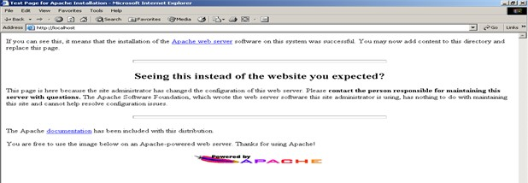

# Steps to Execute PHP Program

Open notepad and type the XML program and save the file with **.php** extension in var/www/html folder.

Open the Mozilla Web browser and type the URL [“h](http://localhost/filename.php)t[tp://localhost/filename.php](http://localhost/filename.php)”

If you create html file as an interface then store the html file in var/www/html folder and access the URL [“ht](http://localhost/filename.html)t[p://local host/filename.html](http://localhost/filename.html)”

The output of the program will be displayed.

Errors in the php file can be known by compiling as **php file name .php** in terminal

**Program No: 1**

In today’s digital world, information dissemination through printed documents consume lot of time. To overcome this drawback it is better to adopt digital technology for information dissemination, like e-journals, e-books, e-advertisements, etc. Information dissemination through Internet in the form of web content is essential and convenient option. Design and develop static web pages for an online Book store. The pages should resemble like www.amazon.com The website should consist of. Home page, Registration & Login, User profile page, Books catalog, Shopping cart, Payment by credit card, and order confirmation.

**Main.html**

<html>

<head>

<title>Main Page</title>

<style type="text/css">

a

{

color:Black;

font-size:large;

}

</style>

</head>

<body style="background-image: url(BgImg2.jpg); background-repeat: no-repeat; background-size: 100%;">

<center>

<h1 style="color:White;">

Main Page</h1>

<br />

<p>

<b><a href="Home.html">Home</a></b>

</p>

<p>

<b><a href="SignUp.html">Register</a></b>

</p>

<p>

<b><a href="Order.html">Order</a></b>

</p>

</center>

</body>

</html>

**Home.html**

<html>

<head>

<title>Home</title>

</head>

<body style="background-image: url(cbgimg1.jpg); background-repeat: no-repeat; background-size: 100%; color:White;">

<center>

<h1>Welcome to e-Books</h1>

</center>

<p>Select your book</p>

<hr />

<center>

<p>

<a href="CheckOut.html"><img src="BgImg1.jpg" height="250" width="250" /></a>

<a href="CheckOut.html"><img src="BgImg1.jpg" height="250" width="250" /></a>

<a href="CheckOut.html"><img src="BgImg1.jpg" height="250" width="250" /></a>

<a href="CheckOut.html"><img src="BgImg1.jpg" height="250" width="250" /></a>

<a href="CheckOut.html"><img src="BgImg1.jpg" height="250" width="250" /></a>

</p>

</center>

<center><a href="MainPage.html">Go to Main page</a></center>

</body>

</html>

**Checkout.html**

<html>

<head>

<title>Checkout</title>

</head>

<body style="background-image: url(cbgimg1.jpg); background-repeat: no-repeat; background-size: 100%; color:White;">

<center><h1>Checkout</h1></center>

<p>Enter Card details</p>

<hr />

Card No : <input type="text" /> <br /><br />

Name on Card : <input type="text" /> <br /><br />

Expiry date : <select >

<option>2018</option>

<option>2019</option>

<option>2020</option>

<option>2021</option>

</select> <br /><br />

CVV No : <input type="text" /> <br /><br />

Amount paid : <input type="text" /> <br /><br />

<input type="submit" value="Submit" /><input type="reset" value="reset" /> <br />

<center>

<a href="MainPage.html">Go to Main Page</a>

</center>

</body>

</html>

**Order.html**

<html>

<head>

<title>Order</title>

</head>

<body style="background-image: url(cbgimg1.jpg); background-repeat: no-repeat; background-size: 100%; color:White;">

<center>

<h1>

Order</h1>

<hr />

<p>

Your Order</p>

<a href="MainPage.html">Go to Main Page</a></center>

</body>

</html>

**Signup.html**

<html>

<head>

<title>Sign up</title>

</head>

<body style="background-image: url(cbgimg1.jpg); background-repeat: no-repeat; background-size: 100%; color:White;">

<center><h1>Sign up</h1></center>

<p>Enter your details</p>

<hr />

First Name : <input type="text" /> <br /><br />

Last Name : <input type="text" /> <br /><br />

Email Id : <input type="text" /> <br /><br />

User Id : <input type="text" /> <br /><br />

Password : <input type="password" /> <br /><br />

Phone No : <input type="text" /> <br /><br />

Day : <input type="text" /> <br /><br />

<input type="submit" value="Submit" /><input type="reset" value="reset" /> <br />

<center>

<a href="MainPage.html">Go to Main Page</a>

</center>

</body>

</html>

**OUTPUT:**

Main.html



Home



Select a book

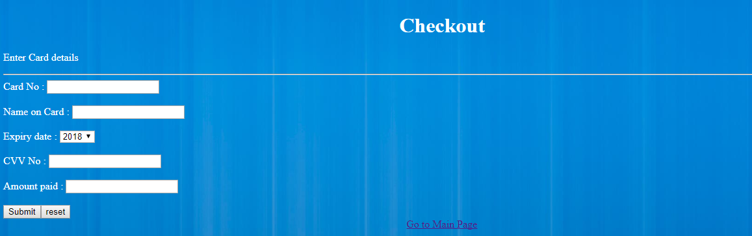

Register

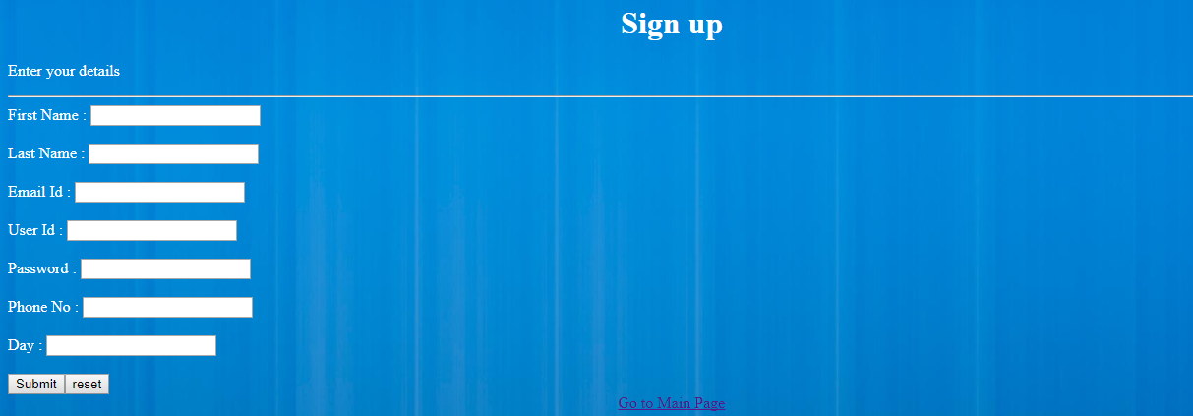

**Program No: 2**

Internet or online services works on clients and server model. A client is a web browser through which users make requests, which contain input required, for service from the server to perform tasks. Server is a program running on a dedicated computer. Performance of any service or server depends on its throughput. Server throughput deteriorates when users send more and more invalid requests for service and thus results in wastage of server resources that are very precious.  As a solution to this problem design a web page that takes student details such as Name, branch, Semester, University, date of admission, mobile number, email id and check for validity or correctness of the input data by writing a JavaScript to validate these fields.

**2.html**

<html>

<head>

<title>Student Registration</title>

</head>

<body>

<div align="Left">

<h1>Student Registration Portal</h1>

<form id="xyz">

<label for="name">Enter name: </label>

<input type="text" id="name" /><br /><hr />

<label for="dob">Select date of birth: </label>

<input type="date" id="dob" /><br /><hr />

<label for="branch">Enter branch: </label>

<input type="text" id="branch" /><br /><hr />

<label for="semester">Select Semester: </label>

<input type="number" id="semester" max="8" min="0" /><br /><hr />

<label for="doj">Select date of joining: </label>

<input type="date" id="doj" /><br /><hr />

<label for="university">Enter University Name: </label>

<input type="text" id="university" /><br /><hr />

<label for="mobile">Enter mobile number: </label>

<input type="text" id="mobile" /><br /><hr />

<label for="email_add">Enter email: </label>

<input type="email" id="email_add" /><br /><hr />

</form>

<button onclick="validate()">Submit</button>

<p>

Result: <span id="result"></span>

</p>

</div>

</body>

<script>

function validate()

{

var result_text = document.getElementById("result");

var dob = document.getElementById("dob").value;

var birth_year = parseInt(dob.substring(0, 4));

var doj = document.getElementById("doj").value;

var join_year = parseInt(doj.substring(0,4));

if (join_year - birth_year < 17)

{

result_text.innerHTML = "Too young to have started college!"

return;

}

var branch = document.getElementById("branch").value;

if (branch.search(/(CSE|ECE|ME|CE|EEE|BCA|MCA)/i) == -1)

{

result_text.innerHTML = "Invalid branch!";

return;

}

var mobile_no = document.getElementById("mobile").value;

if (mobile_no.search(/^[0-9]+$/) == -1 || mobile_no.length != 10)

{

result_text.innerHTML = "Invalid mobile number!";

return;

}

var email = document.getElementById("email_add").value;

if (email.search(/^(([^<>()\[\]\\.,;:\s@"]+(\.[^<>()\[\]\\.,;:\s@"]+)*)|(".+"))@((\[[0-9]{1,3}\.[0-9]{1,3}\.[0-9]{1,3}\.[0-9]{1,3}])|(([a-zA-Z\-0-9]+\.)+[a-zA-Z]{2,}))$/) == -1)

{

result_text.innerHTML = "Invalid email ID";

return;

}

alert('Successfully transmitted data!');

result_text.innerHTML = "Success!";

}

</script>

</html>

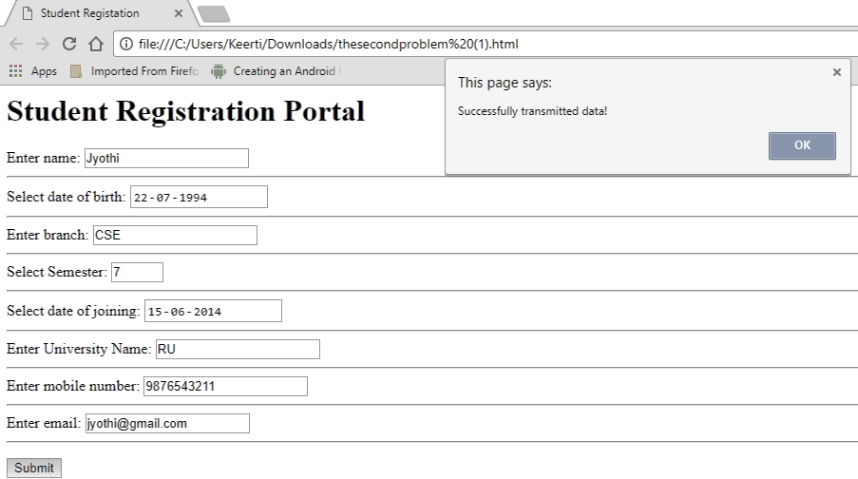

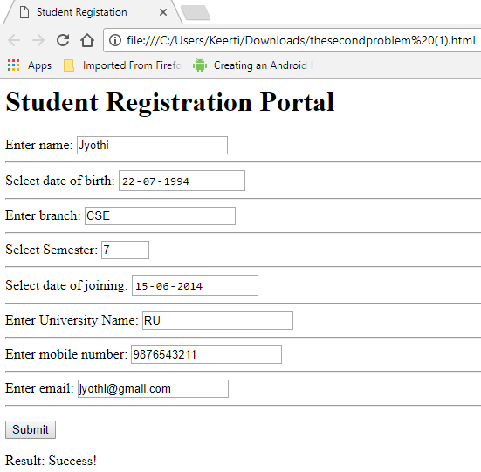

**Program No: 3**

Clients interact with servers by sending service requests that contain input required to complete the requested task or service. Input required for requested service may be collected through a web page, that acts as an interface between users and the server, in the form of text fields, text areas, radio buttons, push buttons and so on. Hence it is better to instruct or help clients to input correct data through web page by displaying appropriate error messages or alerts as and when users supply wrong input using event handlers. To demonstrate this task, design and develop a web page using JavaScript, XHTML that collects the SRN (Valid format is: Any letter followed by two digits, followed by two letters then followed by three digits). Include event handler for the form elements that collects information to validate the input. Messages must be produced in the alert windows as and when errors are detected.

**3.html**

<html>

<head>

<title>Enter the Details</title>

<script>

function validate()

{

var srn = document.getElementById("srn_check").value;

if (srn.search(/^[A-Z a-z]+[0-9]+[0-9]+[A-Z a-z]+[A-Z a-z]+[0-9]+[0-9]+[0-9]+$/) == -1 || srn.length != 8)

{

document.write("Invalid SRN............!!!!!Enter the SRN properly");

return;

}

document.write("Success");

}

</script>

</head>

<body>

<h1>Please enter the following field</h1>

<form>

<labeL>Enter SRN: </label>

<input type="text" id="srn_check" /><br /><hr />

<input type="submit" value="Check" onclick="validate()" />

</form>

</body>

</html>

**OUTPUT:**

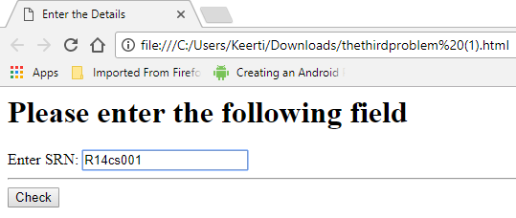

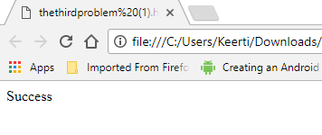

**Program No: 4**

Dynamic web content is the information that is retrieved from one or more web servers depending upon what information client have requested for, and composed in response to users’ requests. Advanced web technologies play a vital role in storage, processing and retrieval of dynamic web content from web servers. Hence it is important to use advanced web technologies such as XML to improve the efficiency in data retrieval. Create and save XML document for students information and display the same using cascaded style sheet.

**4.xml**

<?xml version="1.0" encoding="ISO-8859-1"?>

<?xml-stylesheet type="text/css" href="4.css"?>

<CATALOG>

<STUDENT>

<NAME>Anurag</NAME>

<SRN>R14CS001</SRN>

<BRANCH>CSE</BRANCH>

<SEMESTER>3</SEMESTER>

<UNIVERSITY>REVA</UNIVERSITY>

<COUNTRY >India</COUNTRY>

</STUDENT>

<STUDENT>

<NAME>Arjun</NAME>

<SRN>R14CS021</SRN>

<BRANCH>CSE</BRANCH>

<SEMESTER>5</SEMESTER>

<UNIVERSITY> REVA </UNIVERSITY>

<COUNTRY> India </COUNTRY>

</STUDENT>

<STUDENT>

<NAME>William</NAME>

<SRN>R14CS099</SRN>

<BRANCH>CSE</BRANCH>

<SEMESTER>7</SEMESTER>

<UNIVERSITY> REVA </UNIVERSITY>

<COUNTRY> India </COUNTRY>

</STUDENT>

</CATALOG>

**4.css**

CATALOG

{

background-color: #ffffff;

width: 100%;

}

STUDENT

{

display: block;

margin-bottom: 30pt;

margin-left: 0;

}

NAME

{

color: #FF0000;

font-size: 20pt;

}

SRN

{

color: #0000FF;

font-size: 20pt;

}

BRANCH,SEMESTER,UNIVERSITY,COUNTRY

{

display: block;

color: #000000;

margin-left: 20pt;

}

**OUTPUT:**

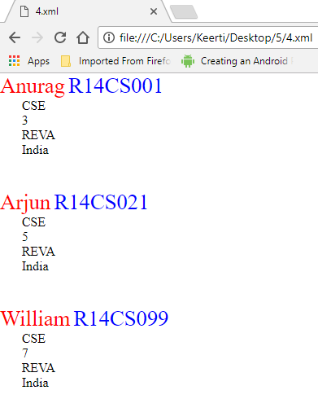

**Program No: 5**

Information technology has become part and parcel of humanity to such an extent that people can shop anything online, from anywhere, at any time using an electronic device that has access to Internet. This has brought in the concept of virtual stores which provide products at less cost. To improve sales it is mandatory to organize items catalog based on item name, item price, and manufacturer so on. For such online shopping sites, look and feel is an obvious requirement which can be achieved using CSS & XSLT. Design a document using CSS and XSLT to create a catalog of items for an online electronic shopping.

**5a.xml**

<?xml version = "1.0"?>

<?xml-stylesheet type="text/css" href="5a.css" ?>

<RU>

<b> Books </b><br />

<e> Electronics </e><br />

<s> Stationaries </s><br />

<c> Cloths</c><br />

<o> other </o><br />

</RU>

**5a.css**

b{ display:block;color:blue;font-style:italic;}

e{ display:block;color:green;font-style:italic;}

s{ display:block;color:red;font-style:italic;}

c{ display:block;color:blue;font-style:italic;}

o{ display:block;color:black;font-style:italic;}

**5b.xml**

<?xml version="1.0"?>

<?xml-stylesheet type="text/xsl" href="5b.xsl" ?>

<RU>

<b> Books </b>

<e> Electronics </e>

<s> Stationaries </s>

<c> Cloths </c>

<o> Other </o>

</RU>

**5b.xsl**

<?xml version = "1.0"?> <xsl:stylesheet version = "1.0" xmlns:xsl = "http://www.w3.org/1999/XSL/Transform" xmlns="http://www.w3.org/1999/xhtml">

<xsl:template match = "RU">

<html><head><title> Style sheet for 5b.xml </title>

</head><body>

<h2> Shopping </h2>

<span style = "font-style: italic; color: blue;"> Books:

</span> <xsl:value-of select = "b" /> <br />

<span style = "font-style: italic; color: blue;"> Electronics:

</span> <xsl:value-of select = "e" /> <br /

<span style = "font-style: italic; color: blue;"> Stationary:

</span> <xsl:value-of select = "s" /> <br />

<span style = "font-style: italic; color: blue;"> Clothes:

</span> <xsl:value-of select = "c" /> <br />

<span style = "font-style: italic; color: blue;"> Others:

</span> <xsl:value-of select = "o" /> <br />

</body>

</html>

</xsl:template>

</xsl:stylesheet>

**OUTPUT:**

**Open 5a.xml in browser**

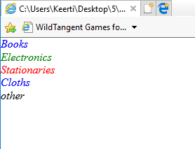

**Open 5b.xml in browser**

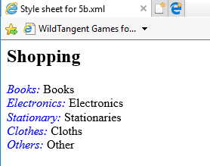

**Program No: 6**

In any business organization, employees keep traveling across different geographical locations and at the same time they want to be connected to their organization’s computing resources such as email server, database server, file server, etc. to retrieve information such as sales details, assigning tasks to employees, and upload inspection site details, so on. Using PHP develop a web page that accepts book information such as ISBN number, title, authors, edition and publisher and store information submitted through web page in MySQL database. Design another web page to search for a book based on book title specified by the user and displays the search results with proper headings.

**book.html**

<html>

<body>

<form action="http://localhost/cgi-bin/bookinsert.php" method="post">

Title: <input type="text"name="title"/>

Author: <input type="text" name="author"/>

Publisher: <input type="text" name="publisher"/>

<input type="submit"/>

</form>

</body>

</html>

**bookinsert.php**

<html>

<body>

<?php

$con = mysql_connect("localhost","root","") or die(mysql_error());

mysql_select_db ("test") or die(mysql_error());

$sql="insert into books (title, author, publisher) values ('$_POST[title]', r]', '$_POST[publisher]')";

if (!mysql_query($sql,$con))

{

die('Error: ' . mysql_error());

}

echo "1 record added";

mysql_close($con);

?>

<form action="bookresult.php" method="post">

Title: <input type="text" name="title" />

<input type="submit" />

</form>

</body></html>

**bookresult.php**

<html>

<body>

<?php

$con = mysql_connect("localhost","root","") or die(mysql_error());

mysql_select_db("test") or die(mysql_error());

$result = mysql_query("select * from books where title= '$_POST[title]'");

if(!$result)

{

echo "There is no record";

}

echo "<table border='1'><tr><th>Title</th><th>Author</th>th>Publisher</th></tr>";

while($row = mysql_fetch_array($result))

{

echo "<tr>";

echo "<td>" . $row['title'] . "</td>";

echo "<td>" . $row['author'] . "</td>";

echo "<td>" . $row['publisher'] . "</td>";

echo "</tr>";

}

echo "</table>";

mysql_close($con);

?>

</body>

</html>

**OUTPUT:**

**Book.html**

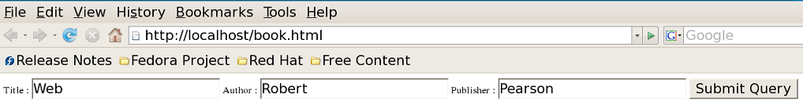

**Bookinsert.php**

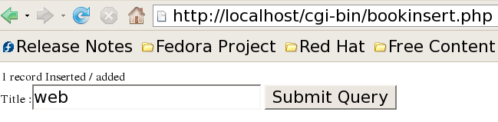

**Bookresult.php**

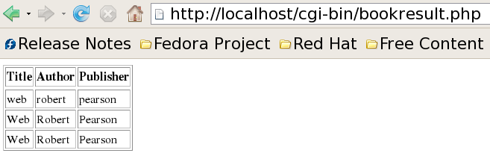

**Program No: 7**

Using computers without graphical user interfaces require the knowledge about syntax of computer commands and programming languages, also this makes users to feel that the use of computers is difficult and cumbersome. This impression of users on computers can be changed by providing good and easy-to-use graphical user interfaces which play vital role in use of computer applications or software without worrying about syntax of programming languages or computer commands. In fact computer software with good and easy-to-use graphical user interfaces will have large number of users. a) Design HTML page that takes UNIX command as input in a text field and submit it to a Perl program that executes given command and display the output on the web page b) Write a Perl program to keep track of the number of visitors to a web page and display the count of visitors with proper headings.

**7.html**

<html>

<head><title>Unix Command</title></head>

<body>

<form method=GET action="http://localhost/cgi-bin/7a.pl" >

<center><br><h1>ENTER UNIX COMMAND TO BE EXECUTED</h1>

<input type="text" name="msg">

<input type="submit" value="CLICKME">

</form>

</body>

</html>

**7a.pl**

#!/usr/bin/perl

use CGI':standard';

print "con tent-type:text/html\n\n";

$c=param('msg');

system($c);

exit(0);

**7b.pl**

#!/usr/bin/perl

print "content-type:text/html ";

$count_file="/var/www/cgi-bin/ru.txt";

if(open(FILE,'<'.$count_file))

{

$no_accesses=<FILE>;

close(FILE);

if(open(FILE,'>'.$count_file))

{

$no_accesses++;

print FILE $no_accesses;

close(FILE);

print "no. of visitors:",$no_accesses;

}

else

{

print "[can't write to data file]";

}

}

else

{

print "[sorry]";

}

exit(0);

**OUTPUT:  
7.html**

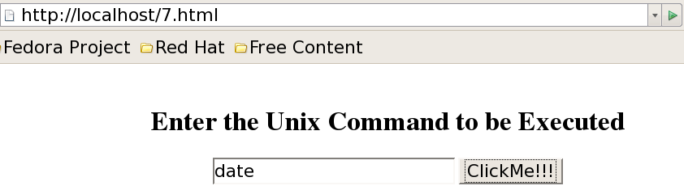

**7a.pl**

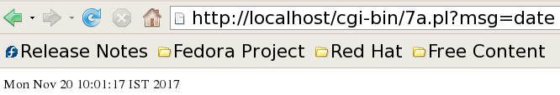

**7b.pl**

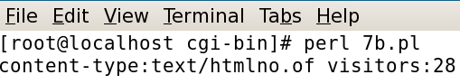

**7b.txt**

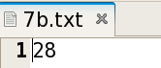

**Program No: 8**

Databases are the storage systems used by most of the business and information technology enterprises as back end. When users generate data using GUI, for ex. personal information, data are sent to back end database for storage and also users can retrieve this data as and when required from the back end (database) to the front GUI. In the real world there are several databases such as Oracle, DB2, MySQL, SQL Server, MS-Access, DBMongo, etc. To illustrate the process of generating data from the front end and store it on back end database then retrieve the available data from the back end database, write a Perl program to read personal information of a person such as first name, last name, age, permanent address and pin code entered by the user into a table created in MySQL. Read the same information from the database and display on the front end.

First Name Last Name Age Address Pincode

Ram Kumar 21 REVA University 560064

Anil Vinay 30 REVA University 560064

**8.html**

<html>

<body>

<form action="http://localhost/cgi-bin/8.pl" method="get">

First Name : <input type="text" name="fname"> <br>

Last Name : <input type="text" name="lname"> <br>

Age : <input type="text" name="age"> <br>

Address : <input type="text" name="address"> <br>

Pincode : <input type="text" name="pincode"> <br>

<input type="submit" value="submit">

</form>

</body>

</html>

**8.pl**

#!/usr/bin/perl

print "content-type:text/html ";

print "<html><title>Result of the insert operation </title>";

use CGI ':standard';

use DBI;

$dbh=DBI->connect("DBI:mysql:test","root","");

$fname=param("fname");

$lname=param("lname");

$age=param("age");

$address=param("address");

$pincode=param("pincode");

$qh=$dbh->prepare("insert into stud values('$fname','$lname','$age','$address','$pincode')");

$qh->execute();

$qh=$dbh->prepare("select * from stud");

$qh->execute();

print "<table border size=1><tr><th>Firstname</th><th>LastName</th><th>Age</th<th>Address</th><th>Pincode</th></tr>";

while ( ($fname,$lname,$age,$address,$pincode)=$qh->fetchrow())

{

print "<tr><td>$fname</td><td>$lname</td><td>$age</td><td>$address</td><td>$pincode</td></tr>";

}

print "</table>";

$qh->finish();

$dbh->disconnect();

print"</HTML>";

**OUTPUT:**

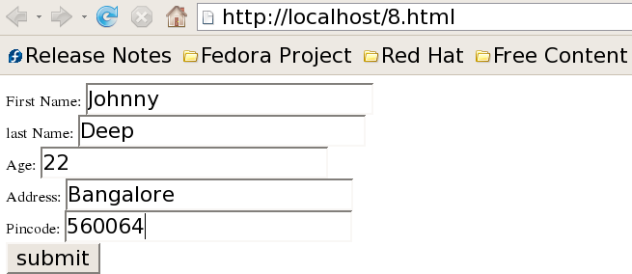



**Program No: 9**

Write a PHP program to store current date-time in a COOKIE and display the ‘Last visited on’ date-time on the web page upon reopening of the same page.

**9.html**

<html >

<head> <title>Cookies</title> </head>

<body>

<form action="http://localhost/cgi-bin/9.php" method="post">

<p> The last visited time was <input type="submit" value="Display Now"/> </p>

</form>

</body>

</html>

**9.php**

<?php

$present_time=date(“H:i:s-m/d/y”);

$expiry= 60 * 60 *24 *60 + time();

setcookie("Lastvisit",$present_time, $expiry);

if(isset($_COOKIE[“Lastvisit”]))

{

echo "Cookie has been set";

echo “The current time of the system is”;

echo $present_time;

echo "The Last visited Time and Date";

echo $_COOKIE["Lastvisit"];

}

else

echo ”You’ve got some old cookies!”;

?>

**OUTPUT:**

**9.html**

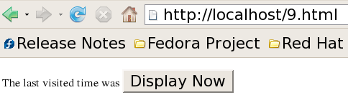

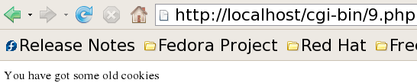

**Program No:10**

Write a PHP program to store page views count in SESSION, to increment the count on each refresh, and to show the count on web page.

**10.html**

<html>

<head> <title>SESSION PROGRAM </title> </head>

<body>

<form action="http://localhost/cgi-bin/10.php" method="post">

<p> To see page views count in session <input type="submit" value="Click Here"/> </p>

</form>

</body>

</html>

**10.php**

<?php

session_start();

if (!isset($_SESSION))

{

$_SESSION["count"] = 1;

echo "<p>Counter initialized</p>\n";

}

else { $_SESSION["count"]++; }

echo "<p>This page has been viewed <b>$_SESSION[count]</b> times.</p>".

"<p>reload this page to increment</p>";

?>

**OUTPUT:**

**10.html**

